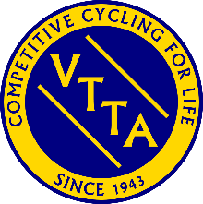

Scottish Cycling and CTT Club Event Result Form
VTTA members who want their:
- results at Scottish Cycling events to be included in the VTTA results database for inclusion in National Season Long Competitions, Standards Awards, Age Records and Scotland VTTA Best All Rounder competitions, or,
- results at Scottish Club events used for Standards Awards,
must complete this form and send it by email or post to the Scotland VTTA Group Recorder. Contact details are on the VTTA website.
Member Firstname
Member Lastname
VTTA membership number
Member Club name
Position in event (optional)
Bib Number (optional)
Machine (tick one) | Solo Bike |  | Solo Trike |  |  | Tandem Bike |  |  | Tandem Trike
Event Name
Event Type (tick one) | Scottish Cycling (SC) |  |  |  |  | CTT Club (Type B)
Event Date and Time
Course Code
Event type (tick one) | 10 | 15 |  | 25 | 30 |  | 50 | 100 |  | Other -please specify
Actual time/distance
hh:mm:ss/n.nn

Admin use only | Date data added to VTTA system

